02-02-2023

JavaScript Concept

DOM

Constructor

Closure

Arrays

Callback

Prototype

Constructor

Events

setTime

setInterval

clearInteval

axios we will use in react js to call rest api

jQuery

JavaScript was object based interpreter scripting language.

ES5.

ECMA Script

ES6, ES7, ES8

Type of functions

Normal function

Expression style function

Arrow function

Callback function

Clouser function

IIFE function

Type of loop

While loop

Do while loop

For loop

For in loop

For of loop

forEach

Array : try to learn all methods.

User defined object :

Set

Map

User defined object

Function style : prototype

Literal style

Class style

Synchronous event

Asynchronous event

setInterval, settime, clearInterval

BOM

DOM

Events

Fetch

Promise

03-02-2023

User defined object :

Object : object is any real world entity.

Properties or state have variable/fields

Object

Behaviour do/does function / methods

Id,name,age,address

Person

teaching(),listening(), sleeping(), learning() etc

Bank

Animal

Car

Student

Customer

In JavaScript object are divided into two types.

Pre defined object

BOM : Browser object model

DOM : document object model

JavaScript follow object hierarchy

Object -🡪property

🡪behaviour

Object --🡪property

Behaviour

Object --🡪property

Behaviour

Object

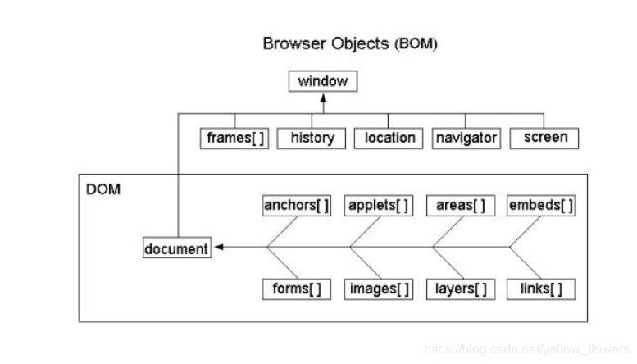

Window is top most object in BOM hierarchy

Window object contains lot of property, behaviour as well as another object.

Document is a property of window object.

If we want to work on browser related information then we need to work on BOM hierarchy.

User defined object

Index.html : if we run this page on browser. Browser internally created DOM Hierarchy

Html -🡪 root

Head body

Title div welcome: textNode

Meta p

Script h1

Style

DOM API (document object model application programming interface).

Lot of programming language java, python, C#, JavaScript provided set of function or methods or classes or modules which help to read, write and update dom element (tags) dynamically.

JavaScript : Event provided bridge between html or dom element to JavaScript code

Event also known as delegation model

In javaScript all event start with pre fix on followed by event name

Like

onClick button

ondblclick button

onMouseOver image

onMouseOut image

onKeyUp textfiled or passwordfiled

onKeyDown

onSubmit submit with validation

onFocus when we enter in textfield

onBlur when we exits from textfield

onChange drop down

etc

In JavaScript we can create user defined object in three ways

1 literal style

2. function style

3. class style

var emp = {id:100,name:”Ravi”,age:21}; // literal style object creation

document.write(“id is “+emp.id);

document.write(“name is “+emp.name);

document.write(“age is “+emp.age);

CORS policy error will generate when frontend and backend technologies

Communicated each other through REST API.

CORS : Cross Origin Resource Sharing

Two domain running

Frontend technology running on 5500 port number

Backend technology running on 3000 port number

We need to enable cors policy in backend technology.

To enable in node js we need to install external module as cors and add this module as middleware to enable cors policy.

npm install cors

if frontend is html, js and css 🡪 using fetch we need to call rest api

if frontend is reac js then 🡪 using fetch or axios plugin we need to call rest api

if frontend is angular 🡪 HttClient using rest api

if front java 🡪RestTemplate